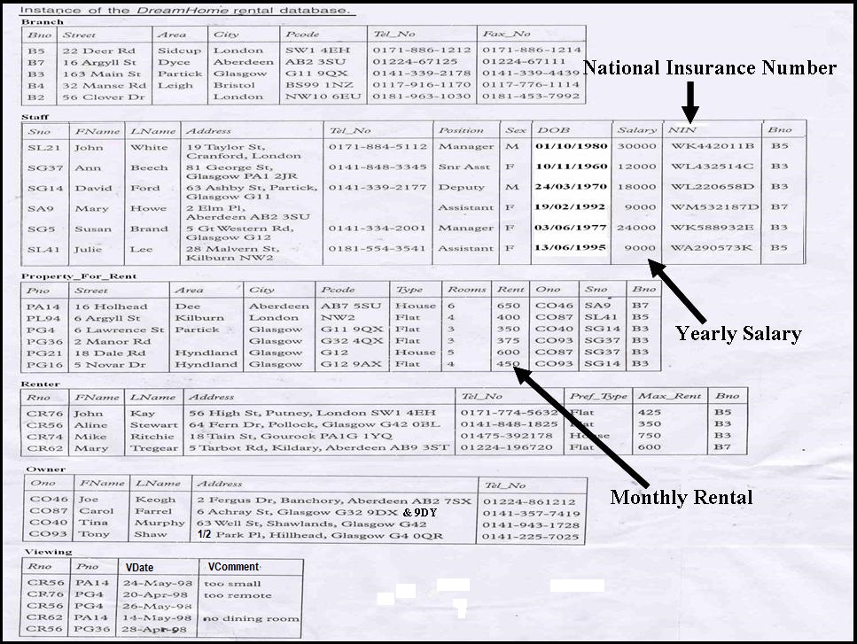

Branch ( Bno, Street, Area, City, Pcode, Tel_No, Fax_No )
Staff ( Sno, FName, LName, Address, Tel_No, Position, Sex, DOB,Salary, NIN, Bno )
Property_For_Rent( Pno, Street, Area, City, Pcode, Type, Rooms, Rent, Ono, Sno, Bno )
Renter ( Rno, FName, LName, Address, Tel_No, Pref_Type, Max_Rent, Bno )
Owner ( Ono, FName, LName, Address, Tel_No )
Viewing ( Rno, Pno, VDate, VComment )

Consider the above DreamHome rental database, write a Structured Query Language (SQL) statement for each of the following operations:

Retrieve All Columns, All Rows
Q01. List full details of all staff.
SELECT *
FROM Staff;

Retrieve Specific Columns, All Rows
Q02. List staff number, first name, last name and salary details for all staff.
SELECT Sno, FName, LName, Salary
FROM Staff;

Retrieve Specific Columns, Some Rows
Q03. List staff number, first name, last name and salary details for staff with staff number'SL21'.
SELECT Sno, FName, LName, Salary
FROM Staff
WHERE Sno = ‘SL21’; / Sno LIKE ‘SL21’;

Calculate Fields
Q04. Produce a list of monthly salaries for all staff, showing the staff number, first name, last name and the salary details.
SELECT Sno, FName, LName, Salary / 12 AS MonthySalary
FROM Staff;

Sorting Results (Ascending - ASC)
Q05. Produce a list of salaries for all staff, arranged in ascending order of salary.
SELECT Sno, FName, LName, Salary
FROM Staff
ORDER BY Salary;

Sorting Results (Descending - DESC)
Q06. Produce a list of salaries for all staff, arranged in descending order of salary.
SELECT Sno, FName, LName, Salary
FROM Staff
ORDER BY Salary DESC;

Sorting Results (Multiple Columns)
Q07. Produce an abbreviated list of properties arranged in order of property type and in descending order of rent within the same property type.
SELECT Pno, Type, Rooms, Rent
FROM Property_For_Rent
ORDER BY Type, Rent DESC;

Joining Database Tables (Retrieve Data)
Q08. List the names of all renters who have viewed a property along any comment supplied.
SELECT Renter.Rno, FName, LName, Pno, VComment
FROM Renter, Viewing
WHERE Renter.Rno = Viewing.Rno;

SELECT R.Rno, FName, LName, Pno, VComment
FROM Renter R, Viewing V
WHERE R.Rno = V.Rno AND VComment IS NOT NULL; // comment cannot be empty

Joining Database Tables (Check Condition)
Q09. List the staff who work in the branch at street '163 Main St'.
SELECT Sno, FName, LName, Position, Salary
FROM Staff S, Branch B
WHERE S.Bno = B.Bno AND Street = ‘163 Main St’;

SELECT Sno, FName, LName, Position, Salary
FROM Staff
WHERE Bno = (SELECT Bno
FROM Branch
WHERE Street = ‘163 Main St’);

SELECT Sno, FName, LName, Position, Salary
FROM Staff
WHERE Bno = (SELECT Bno
FROM Branch
WHERE Street IN (‘163 Main St’, ’22 Deer Rd’));

Joining Database Tables ( Sorting Results – 2Tables )
Q10. For each branch office, list the names of staff who manage properties, and the properties they manage. Arrange the branch number, staff number and property number in ascending order.

Joining Database Tables ( Sorting Results –3 Tables )
Q11. For each branch, list the staff who manage properties, including the city in which the branch is located and the properties they manage. Arrange the branch number, staff number and property number in ascending order.
Using Comparison Operator on Character Field
Q12. List all staff with a staff number less than or equal to 'SG37'.

Using Comparison Operator on Numeric Field
Q13. List all staff with a salary greater than $10000.
Using Comparison Operator on Date Field
Q14. List the details of all viewings made on May 1998.
Logical Operators (OR)
Q15. List the address of all branch offices in 'London' or 'Glasgow'.

Logical Operators (AND)
Q16. List the address of branch office in Sidcup, London.

Logical Operators (NOT)
Q17. List all staff with a staff number that not equal to 'SG37'.
SELECT Sno, FName, LName, Position, Salary
FROM Staff
WHERE Sno != ‘SG37’;

SELECT Sno, FName, LName, Position, Salary
FROM Staff
WHERE Sno <> ‘SG37’;

SELECT Sno, FName, LName, Position, Salary
FROM Staff
WHERE Sno NOT LIKE ‘SG37’;

Logical Operators (AND, OR)
Q18. List all female managers and assistants.
SELECT Sno, FName, LName, Position, Salary
FROM Staff
WHERE (Position = ‘Manager’ OR Position = ‘Assistant’) AND Sex = ‘F’;

SELECT Sno, FName, LName, Position, Salary
FROM Staff
WHERE Position IN (‘Manager’, ‘Assistant’) AND Sex = ‘F’;

SELECT *
FROM (SELECT Sno, FName, LName, Position, Salary
FROM Staff
WHERE Position IN (‘Manager’, ‘Assistant’))
WHERE Sex = ‘F’;

(SELECT Sno, FName, LName, Position, Salary
FROM Staff
WHERE Position = ‘Manager’ AND Sex = ‘F’)
UNION
(SELECT Sno, FName, LName, Position, Salary
FROM Staff
WHERE Position = ‘Assistant’ AND Sex = ‘F’);

Special Operators (DISTINCT)
Q19. List the property numbers of all properties that have been viewed.
SELECT Pno
FROM Viewing;

List the different properties that have been viewed.
SELECT DISTINCT Pno
FROM Viewing;

Special Operators (BETWEEN)
Q20. List all staff with a salary between $20000 and $30000.
SELECT Sno, FName, LName, Position, Salary
FROM Staff
WHERE Salary BETWEEN 20000 AND 30000;

WHERE Salary >= 20000 AND Salary <= 30000;

SELECT *
FROM (SELECT Sno, FName, LName, Position, Salary
FROM Staff
WHERE Salary >= 20000)
WHERE Salary <= 30000;

Special Operators (NOT BETWEEN)
Q21. List all staff with a salary not between $20000 and $30000.
SELECT Sno, FName, LName, Position, Salary
FROM Staff
WHERE Salary NOT BETWEEN 20000 AND 30000;

WHERE Salary < 20000 OR Salary > 30000;

WHERE NOT (Salary BETWEEN 20000 AND 30000);

Special Operators (IS NULL)
Q22. List the details of all viewings on property PG4 where a comment has not been supplied.
SELECT Rno, VDate
FROM Viewing
WHERE Pno = ‘PG4’ AND VComment IS NULL;

Special Operators (IS NOT NULL)
Q23. List the details of all viewings on property PG4 where a comment has been supplied.
SELECT Rno, VDate, VComment
FROM Viewing
WHERE Pno = ‘PG4’ AND VComment IS NOT NULL;

Special Operators (LIKE)
Q24. Find all staff with the string 'Glasgow' in their address.
SELECT Sno, FName, LName, Position, Salary
FROM Staff
WHERE Address LIKE ‘%Glasgow%’;

SELECT Sno, FName, LName, Position, Salary
FROM Staff
WHERE UPPER(Address) LIKE ‘%GLASGOW%’;

Special Operators (NOT LIKE)
Q25. List all owner details without the starting string '0141-' in their telephone number.
SELECT *
FROM Owner
WHERE Tel_No NOT LIKE ‘0141-%’;

Special Operators (IN / EXISTS) - Subquery
Q26. List the staff who work in the branch at street '163 Main St' or '22 Deer Rd'.
SELECT Sno, FName, LName, Position, Salary
FROM Staff
INNER JOIN Branch ON Staff.Bno = Branch.Bno
WHERE Street IN (‘163 Main St’, ‘22 Deer Rd’);

SELECT Sno, FName, LName, Position, Salary
FROM Staff
WHERE Bno IN (SELECT Bno
FROM Branch
WHERE Street IN (‘163 Main St’, ‘22 Deer Rd’);

SELECT Sno, FName, LName, Position, Salary
FROM Staff S
WHERE EXISTS (SELECT *
FROM Branch B
WHERE S.Bno = B.Bno AND Street IN (‘163 Main St’, ‘22 Deer Rd’);

Special Operators (NOT IN / NOT EXISTS) - Subquery
Q27. Find all the staff that not handles any property.
SELECT Sno, FName, LName, Position, Salary
FROM Staff
WHERE Sno NOT IN (SELECT DISTINCT Sno
FROM Property_For_Rent);

SELECT Sno, FName, LName, Position, Salary
FROM Staff S
WHERE NOT EXISTS (SELECT *
FROM Property_For_Rent P
WHERE S.Sno = P.Pno);

Aggregate Functions: COUNT (*)
Q28. How many properties cost more than $350 per month to rent?
SELECT COUNT(*) AS PropertyCount
FROM Property_For_Rent
WHERE Rent > 350;

SELECT COUNT(Pno) AS PropertyCount
FROM Property_For_Rent
WHERE Rent > 350;

NOTE:
COUNT(*) = count number of rows in table
COUNT(Pno) = count number of rows in Pno attribute (Skip the NULL value)

SELECT COUNT(*) = 5
FROM Viewing;

SELECT COUNT(VComment) = 3
FROM Viewing;

Aggregate Functions: COUNT (DISTINCT)
Q29. How many different properties were viewed in May 1998?
SELECT COUNT(DISTINCT Pno) AS DifferentPropertyCount
FROM Viewing
WHERE VDate BETWEEN ‘01-May-1998’ AND ’31-May-1998’;

Aggregate Functions: COUNT( ), SUM( )
Q30. Find the total number of Managers and the sum of their salaries.
SELECT COUNT(Sno) AS ManagerCount, SUM(Salary) AS SumSalary
FROM Staff
WHERE Position = ‘Manager’;

Aggregate Functions: SUM (Expression)
Q31. Project the total amount of monthly rental collections before and after 10% increment, and include the different value between them, if all the properties are rented out.
SELECT SUM(Rent) AS CollectionBeforeIncrement,
SUM(Rent * 1.1) AS CollectionAfterIncrement,
SUM(Rent * 1.1) – SUM(Rent) AS DifferentValue
FROM Property_For_Rent;

Aggregate Functions: MIN( ), MAX( ), AVG( )
Q32. Find the minimum, maximum and average staff salary.
SELECT MIN(Salary) AS MinSalary
MAX(Salary) AS MaxSalary
AVG(Salary) AS AvgSalary
FROM Staff;

Aggregate Functions: Subqueries - MAX( )
Q33. List the staff number, first name, last name, position and salary of staff who get the highest salary.
SELECT Sno, FName, LName, Position, Salary
FROM Staff
WHERE Salary = (SELECT MAX(Salary)
FROM Staff);

Aggregate Functions: Subqueries - MIN( )
Q34. List the staff number, first name, last name and his/her monthly salary which is the lowest.
SELECT Sno, FName, LName, Position, Salary/12 AS MonthlySalary
FROM Staff
WHERE Salary = (SELECT MIN(Salary)
FROM Staff);

Aggregate Functions: Subqueries - AVG( )
Q35. List all staff whose salary is greater than the average salary, and list by how much their salary is greater than average.
SELECT Sno, FName, LName, Position,
Salary – (SELECT AVG(Salary) FROM Staff) AS SalDiff
FROM Staff
WHERE Salary > (SELECT AVG(Salary) FROM Staff);

Grouping Result: GROUP BY – Single Grouping Column
Q36. Find the number of staff working in each branch and the sum of their salaries. Arrange the result in ascending order of branch number.

Note:
Make sure within query consists of SUM()/COUNT()…

SELECT Bno, COUNT(*) AS NoOfStaff, SUM(Salary) AS SumSalary
FROM Staff
GROUP BY Bno
ORDER BY Bno;

Grouping Result: GROUP BY – Multiple Grouping Columns
Q37. Find the number of properties handled by each staff member from different branches. Arrange the result in ascending order of branch number and staff number.
SELECT S.Bno, S.Sno, COUNT(P.Pno) AS PHCount
FROM Staff S, Property_For_Rent P
WHERE S.Sno = P.Sno
GROUP BY S.Bno, P.Sno
ORDER BY S.Bno, P.Sno;

Restricting GROUP BY Using HAVING
Q38. For each branch office with more than one member of staff, find the number of staff working in the branch and the sum of their salaries. Arrange the result in ascending order of branch number.
SELECT Bno, COUNT(Sno) AS NoOfStaff, SUM(Salary) AS SumSalary
FROM Staff
GROUP BY Bno
HAVING COUNT(Sno) > 1
ORDER BY Bno;

Special Function (TRUNC(): Cut off the decimal point)
Q39. List all the staff name and his/her age between the age of 30 to 50 years old.

SELECT FName, LName, TRUNC((SYSDATE – DOB) / 365.25) AS Age
FROM Staff
WHERE (TRUNC((SYSDATE – DOB) / 365.25) BETWEEN 30 AND 50;

Special Function (EXTRACT(): Extract the value)
Q40. List all the staff name (full name = first name + last name) and his/her age that more than 21 years old.

Special Keyword (ROWNUM)
Q41. List the top 3 highest salary’ staff with their staff number, first name, last name and salary amount.

EXTRA EXERCISE (Homework):
E01. List all the staff with his/her staff number, staff name and position who work at London.

E02. For each staff, list the staff number, first name, last name, number of property handled for those staff that handles any properties.

E03. For each staff, list the staff number, first name, last name, number of property handled for those staff that handles more than 1 property.

E04. For each staff, list the staff number, first name, last name for those staff that did not handles any properties.

E05. For each staff, list the staff number, first name, last name, number of property handled for those staff that handles any properties. Arrange your output for number of property handled in descending order.

E06. For each staff, list the staff number, first name, last name, number of property handled for those staff that handles more than 1 property. Arrange your output for first name in ascending order.

E07. List the renter number, renter name, property number, property address, property owner name, date viewed and comment for property that being viewed.

E08. For each branch, list the branch number, branch city and its total monthly salary for all its staff.

E09. For each branch, list the branch number, branch city and its total monthly salary for all its staff which more than 3000.

E10. List all the staff name and his/her age between the age of 40 to 60 years old and the salary between 5,000 to 20,000.

E11. List all the area and city of branch with post code that end with 'H','U','X'.

E12. List all staff details with the salary more than or equals to average.

E13. How many staff earn more than David Ford.

E14. Find the different between the higher salary and lowest salary.

Single Row Insertion (INSERT INTO …. VALUES): Supply all values
Q42. Insert a new record into the staff table supplying data for all columns.

Single Row Insertion (INSERT INTO …. VALUES): Supply some values
Q43. Insert a new record into the staff table supplying data for all mandatory columns: Sno, FName, LName, Position, Sex, Salary and Bno.

Multiple Rows Insertion (INSERT INTO …. SELECT)
Q44. Populate the Staff_Handling_Count table using details from the Staff and Property_For_Rent tables.

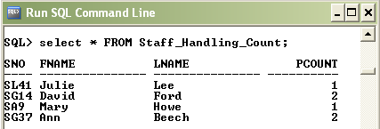

NOTE: Assume Staff_Handling_Count table already created in DreamHome database.
UPDATE All Rows
Q45. Give all staff a 3% pay increase.

UPDATE Specific Rows
Q46.Give all managers a 5% pay increase.

UPDATE Multiple Columns
Q47. Promote David Ford (Sno = 'SG14') to manager and change his salary to RM 18000.

UPDATE By Reference
Q48. Give all staff that works at London a 5% pay increase.

DELETE All Rows
Q49. Delete all records from the viewing table.

DELETE Specific Rows
Q50. Delete all viewings that relate to property PG4.

DELETE By Reference
Q51. Delete all viewings that relate to any property at Glasgow.

ALTER TABLE: Changing Column Characteristics
Q52. Change the characteristic of Tel_No attribute on Branch table from VARCHAR(13) to VARCHAR(14).

ALTER TABLE: Adding a Column to the Table
Q53. Add the Branch_Email attribute on Branch table with data type VARCHAR(50).

ALTER TABLE: Dropping a Column from the Table
Q54. Delete the Fax_No attribute on Branch table.

ALTER TABLE: Set and Drop the Default Value
Q55. Change the Staff table by removing the default of ‘M’ for the Sex column and setting the default for the Position column to ‘Assistant’.

DROP TABLE: Removing the Table
Q56. Delete the Branch table.

